Background

Let it be a Telephone tag, a Chinese wall or even a simple handshake, Communication forms an integral and necessary part of our day to day lives. It is the bedrock for interpersonal relations and also a medium for exchange of information and ideas between two individuals. Similarly in a Computer system environment we find the necessity for the communication of two active processes in the functioning of certain compound tasks. This communication is facilitated by what we call as the IPC.
Inter-process communication (IPC) is a set of techniques for the exchange of data among multiple threads in one or more processes. Traditionally the term describes various ways of message passing between different processes that are running on an operating system or in a network of computers. Conceptually, coordination is implemented by some form of active or passive communication. In addition it also describes the various forms of synchronisation available as newer forms of communication, such as message passing; shared memory and other methods require synchronisation. One of the advantages of using IPCs is that programs can take advantage of processes handled by other programs or computers.
Message passing is a style of IPC in which processes containing data or simply an identification tag can send discrete messages directly to one another. Message passing is developed particularly for problems run on distributed and parallel processing systems. However, because the commercial message-passing RTOSs of today provide high performance and can be easily debugged, programmed and maintained, they are equally valuable for both single CPU systems and distributed systems. The client/server model takes advantage of RPCs, as do distributed object architectures such as Microsoft's DCOM and CORBA (Common Object Request Broker Architecture) are a few examples on Message passing

Literature

Primitive communications:

    - Lock Files:

A lock file can be used by processes as a way to communicate with one another. The processes involved may be different programs or multiple instances of the same program. The use of lock files has a long history In UNIX, as earlier versions used lock files as a means of communication.
The theory behind the use of lock file as an inter process - communication technique is rudimentary. In brief, by using an agreed-upon-file-naming convention, a process examines a prearranged location for the presence or absence of a lock file. In its most basic form, if the file is present, the process takes one set of actions, and if the file is missing, it takes another.

Sockets:

A socket is a software abstraction that is used to create a channel-like interface between processes. The channel allows bi-directional communication between processes, but does little to structure the data being transmitted. Communication between processes via sockets can be viewed as streams or diagrams. Stream-based communication views transmitted data as a sequence of bytes, whereas datagram-based communication deals with small discrete packets of information. These packets typically contain header and trailer information in addition to the data being transmitted. Choosing a socket type is important, because each has different performance and reliability characteristics, and two communicating sockets must be of the same type.

Signals:

The second primitive inter process communication technique involves the use of signals. Signals, which can be sent by processes or the kernel, serve as notification that an event has occurred. Signals are generated when the event first occurs and are considered to be delivered when the process takes action on the signal. The delivery can be blocked so that no signals can be acted upon later.

Pipes

In Unix-like computer operating systems a pipeline is the original software pipeline: a set of processes chained by their standard streams, so that the output of each process feeds directly as input to the next one. Each connection is implemented by an anonymous pipe. Pipelines can be created under program control. The UNIX pipe () system call asks the operating system to construct a new anonymous pipe object. This results in two new, opened file descriptors in the process: the read-only end of the pipe, and the write-only end. The pipe ends appear to be normal, anonymous file descriptors, except that they have no ability to seek.

Named Pipes

A Named pipe is an extension to the traditional pipe concept on UNIX and Unix-like systems, and is one of the methods of inter-process communication. The concept is also found in Microsoft Windows, although the semantics differ substantially. A traditional pipe is "unnamed" because it exists anonymously and persists only for as long as the process is running. A named pipe is system-persistent and exists beyond the life of the process and must be deleted once it is no longer being used. Processes generally attach to the named pipe to perform inter-process communication.

  - Message Passing:
Message passing is a form of communication in inter-process communication where processes or objects can send and receive messages to other processes. This allows the processes to communicate and synchronizes their actions without sharing the same address space and is particularly useful in a distributed environment. Message passing is the paradigm of communication where messages are sent from a sender to one or more recipients. Forms of messages include (remote) method invocation, signals, and data packets.

    - Characteristics of message passing:

- Is based on two primitives:
- send (destination, &message)
- Sends a message to a destination
- receive (source, &message)
- Receives a message from a source (any source)
- System calls, not language constructs
- Blocking versions and non-blocking versions are available

Overview Of Message Passing

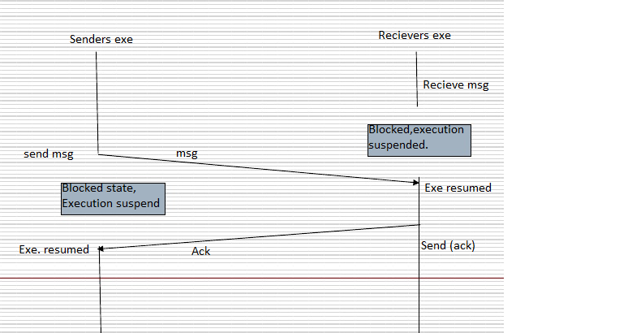

Classification:
If two processes want to communicate, they must send messages to and receive messages from each other; a communication link must exist between them. We are concerned here not on the link’s physical implementation rather its logical implementation.
This link can be implemented in a variety of ways as follows:
- Direct or Indirect communication
- Synchronous or asynchronous communication
- Automatic or explicit buffering

Naming: Direct Communication

- Sender/receiver refers to each other, as seen before

- Properties of communication link
- Link is established automatically between communicating processes
- Link is associated with exactly two processes
- Exactly one link for every pair of processes

- Communication is symmetric (above) or asymmetric
- send(P,m) // send a message to P
- receive(&id, m) // receive from any process, set id to sender

Naming: Indirect Communication

- Communication via mailboxes (or ports)

- Processes communicate by putting and taking messages in/from mailboxes
- send(A, m) and receive(A,m)

- Properties of communication link
- A link is established between two processes, if they share a mailbox
- Link maybe associated with more than two processes
- A number of different links may exist between any pair of processes; each one a separate mailbox

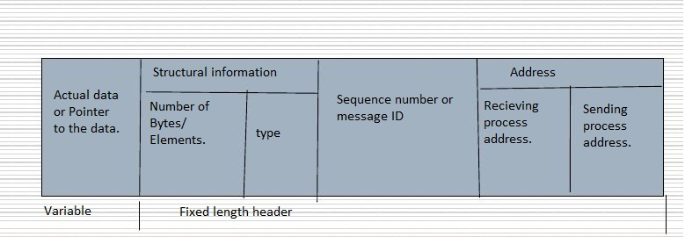

Synchronisation:

Communication between processes takes place through calls to send () and receive primitives. There are different design options for implementing each primitive .Message passing may be either blocking or non-blocking also known as synchronous or asynchronous.
Blocking send: The sending process is blocked until the message is received by the receiving process or the mailbox.
Non-Blocking send: The sending process sends the message and resumes operation.
Blocking receive: The receiver blocks until a message is available.
Non-blocking receive: The receiver retrieves a valid message or null.

Buffering:

The mechanism that buffers messages (aka queue) may have the following properties:

Zero capacity: queue has length 0, no messages can be outstanding on link, sender blocks for message exchange

Bounded capacity: queue has length N, N messages can be in queue at any point in time, sender blocks if queue is full, otherwise it may continue to execute

Unbounded capacity: queue has infinite length,sender never blocks

Implementation Overview Of Message Passing:

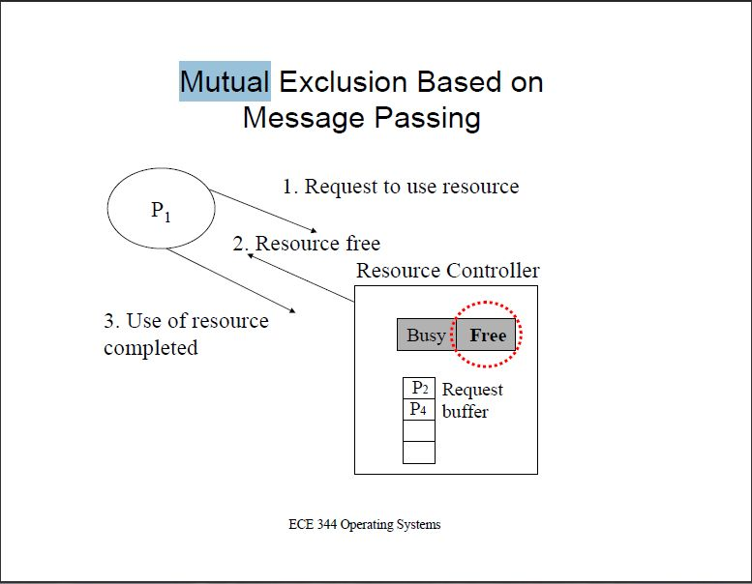

Desirable Features Of A Good Message Passing System :

- Simplicity ( To construct new applications. and to communicate with existing ones)
- Uniform Semantics
Local communication (communicating processes r on the same node)
Remote communication (communicating processes r on diff. nodes )
- Efficiency (critical issue, cost effective)
- Optimizations
Reducing the number of message exchanges min. the cost of maintaining the connections piggybacking.
- Reliability (D.S is prone to node crashes or communication link failure)
lost messages.
Duplicate messages. (A reliable IPC protocol is reqd.)
- Correctness (A characteristic for group communication.)
Atomicity
Ordered delivery
Survivability
- Flexibility ( not all applications. require same degree of correctness and reliability)
- Desirable features of a good Message passing system
- Simplicity ( to const. new applications. and to communicate with existing ones)
- Uniform Semantics
Local communication. (communicating processes are on the same node)
Remote communication.(communicating processes are on different nodes )
- Efficiency ( critical issue, cost effective)
- Optimization
reducing the no. of msg. exchanges min. the cost of maintaining the connections piggybacking.
- Reliability (D.S is prone to node crashes or communication. link failure)
lost messages, duplicate messages. (A reliable IPC protocol is reqd.)
- Correctness (A characteristic for group communication.)
Atomicity, Ordered delivery, survivability
- Flexibility ( not all applications. require same degree of correctness and
- reliability
- Security
Authentication
Encryption etc.
- Portability (Two aspects)
Message passing system should itself be portable ( on another sys.)
Applications written by using the primitives of the IPC protocols should be portable.
- Heterogeneity (architectures) should be taken care of.

Findings

Message Passing In MPI

The commercial message-passing RTOSs of today provide high performance and can be easily debugged, programmed and maintained, they are equally valuable for both single CPU systems and distributed systems. The client/server model takes advantage of RPCs, as do distributed object architectures such as Microsoft's DCOM and CORBA (Common Object Request Broker Architecture) are a few examples on Message passing

Message Passing In Windows

The Windows operating system provides mechanisms for facilitating communications and data sharing between applications. Collectively, the activities enabled by these mechanisms are called interprocess communications (IPC). Some forms of IPC facilitate the division of labor among several specialized processes. Other forms of IPC facilitate the division of labor among computers on a network.

Message Passing In Mail Slots

In Mail slots we implement message passing IPC technique which combines the good features of these techniques and also provides a set of new aspects so that the user processes can get a more flexible, adaptable and easy to use means of communication

Message Passing In Micro Kernels

Communication takes place between user modules using message passing in micro kernels.

Further Inter-process communication mechanisms

System V IPC Mechanisms

Linux supports three types of interprocess communication mechanisms that first appeared in Unix System V (1983). These are message queues, semaphores and shared memory. These System V IPC mechanisms all share common authentication methods. Processes may access these resources only by passing a unique reference identifier to the kernel via system calls

Message Queues

Message queues allow one or more processes to write messages, which will be read by one or more reading processes. Linux maintains a list of message queues, the msgque vector; each element of which points to a msqid_ds data structure that fully describes the message queue.

Semaphores

In computer science, a semaphore is a protected variable or abstract data type that provides a simple but useful abstraction for controlling access by multiple processes to a common resource in a parallel programming environment. It is a programming construct designed by E. W. Dijkstra in the late 1960s.

Shared Memory

Shared memory allows one or more processes to communicate via memory that appears in all of their virtual address spaces. The pages of the virtual memory are referenced by page table entries in each of the sharing processes' page tables. It does not have to be at the same address in all of the processes' virtual memory. As with all System V IPC objects, access to share memory areas is controlled via keys and access rights checking.

Conclusion

In this literature review we have clearly presented a brief description of all the inter process communications available prior and post to message passing technique. The review includes a detail dissertation on message passing and has a pragmatic approach to understanding and implementation of this concept. In addition we have outlined some applications where message passing is used and how higher order techniques progressed through inheriting the advantages of message passing. We conclude by stating that this review forms a research basis to approaching message passing communication.

References

http://books.google.co.in/books?id=pF2ka_E_R5YC&pg=PA118&lpg=PA118&dq=history+of+interprocess+communication&source=bl&ots=llt76com2&sig=JypYo3L_AvN0lKEnUVYFkoJvxdU&hl=en&ei=AILmTO2jIMrqOcqPnN8K&sa=X&oi=book_result&ct=result&resnum=7&ved=0CEgQ6AEwBg#v=onepage&q=history%20of%20interprocess%20communication&f=true

http://www.scribd.com/doc/6919735/MessagePassing1

http://en.wikipedia.org/wiki/Inter-process_communication

http://webcache.googleusercontent.com/search?q=cache:UhK7T9aPx4sJ:itcs322.almahdi.cc/chap3.doc+message+passing+between+processes+os&cd=7&hl=en&ct=clnk&gl=in&client=firefox-a

